**Simultaneous radiation and corrosion on SS316L in liquid lead-4bismuth alloy**

Wande Cairang1, Weiyue Zhou2, *, Yong Zhang3, Paola Amadeo4, Kevin B. Woller2, Michael P. Short1,2,*

*1* *Department of Nuclear Science and Engineering,* *Massachusetts Institute of Technology, Cambridge, MA 02139, USA*

*2* *Plasma Science and Fusion Center (PSFC), Massachusetts Institute of Technology, Cambridge, MA 02139, USA*

*3 Characterization.nano, Massachusetts Institute of Technology, MA 02139, USA*

*4 Department of Materials Science and Engineering, Massachusetts Institute of Technology, MA 02139, USA*

**Abstract:**

Investigating the coupling effects of radiation and corrosion in lead-based liquid alloys holds significance for both fission and fusion applications. However, existing literature lacks comprehensive data on how radiation influences corrosion in reducing lead-based liquid alloys. In this study, simultaneous radiation and corrosion experiments were conducted on Stainless Steel (SS)316L in liquid lead-4wt% bismuth (Pb-4Bi) at 675°C, utilizing 3MeV proton irradiation. The results reveal that radiation enhances both the initiation and development of liquid Pb-4Bi corrosion. The acceleration in corrosion initiation could be attributed to the radiation-induced enhancement in wetting on the surface, while the speeding up in corrosion development could be a result of increased bulk diffusion of Ni through point defects and movement of interstitial loops during radiation. This research provides insights into the corrosion mechanisms of SS316L in liquid lead-bismuth alloy, as well as elucidates the impact of radiation on this process.

**1. Introduction**

Lead-based liquid alloys show significant promise in nuclear systems owing to their excellence in neutronic, thermohydraulic, and chemical stability properties [1-4]. For instance, lead lithium alloys exhibit potential as tritium breeder blankets in fusion, while lead bismuth alloys, such as Lead Bismuth Eutectic (LBE) are regarded as favorable working fluids and spallation targets in Lead-based Fast Reactors (LFRs) and Accelerator-Driven Subcritical systems (ADS) [5-7]. However, the challenging conditions of these liquids present obstacles to the application of structural materials. One of the most pressing concerns is liquid metal corrosion (LMC) of structural materials, where materials experience either selective element dissolution or oxidation upon exposure to these liquids [8]. In addition to corrosion at high temperatures, the materials also contend with high-energy neutron radiation in practical applications. The introduction of high-energy radiation further imposes challenges on material selection by complicating the corrosion process where radiation would affect both structure and chemistry of the oxide layer [9, 10]. The exploration of the synergy between radiation and corrosion is still in its early stages, mainly attributed to the high cost, intricate experimental design, and complex underlying mechanisms involved [11-13]. This complexity renders it one of the most challenging tasks, hindering the deployment of advanced nuclear reactors. Initial investigations into the interplay between radiation and corrosion have been employed in various corrosion mediums, including high-temperature water [14-17], molten salt [18-20], and liquid lead-based alloys [13, 21-23]. These studies have revealed that radiation can have various effects on corrosion process. For instance, Wang, P. et al. [15] observed that simultaneous proton radiation enhances the oxidation rate of Zircaloy-4 in simulated Pressure Water Reactor (PWR) primary water, leading to a thicker and porous oxide layer on the irradiated sample compared to the thinner oxide layer on the corrosion-only sample. In contrast, Zhou et al. [19] present an opposing scenario where proton radiation decelerates intergranular corrosion of Ni-Cr alloy in molten salt. This is evidenced by a much shallower corrosion penetration in the radiated-affected corrosion region compared to the deeper penetration in corrosion-only regions.

In the investigation of the influence of radiation on the corrosion of liquid lead-based alloy, it has been shown that radiation could enhance the growth of the oxide layer and induce its structural changes [21, 23]. C. Yao et al. [21] carried out a study on the oxidation behavior of Si-added martensitic steel simultaneously exposed to a 247 MeV Ar ion with 1.36 dpa while subjected to 350 ℃ flowing liquid LBE. The results indicate that ion radiation not only enhances the oxidation rate by accelerating the formation of oxides but also modifies the structure of the oxides. The outer layer consists of an amorphous composition of Fe3O4+PbO/Pb, followed by a middle magnetitic layer and an amorphous inner layer of Cr2O3, SiO2. The enhancement of oxide formation may be attributed to radiated-enhanced diffusion, although a deeper understanding still requires further investigation. Contrastingly, Q. Chen et al. [13] observed no amorphization of the oxide layer, both in the outer and inner layers, in 11Cr1Si ferritic/martensitic steel when irradiated by 6 MeV protons at nearly 400 ℃. Instead, they found an increase in the thickness of these layers, and it becomes more pronounced with higher ion fluences. This increase in oxide thickness was attributed to the outward long-distance diffusion of Fe atoms and the inward diffusion of O atoms. In their most recent study, Q. Chen et al. [24] conducted simultaneous radiation and corrosion tests on 11Cr1W1Si using 5 MeV protons for 17 hours, reaching a cumulative fluence of 1.7 × 1017 ions/cm2, while exposed to oxygen-saturated liquid lead-bismuth eutectic (LBE) at 400 °C. The results once again confirmed the absence of structural changes in the oxide due to radiation. However, there was an observed increase in thickness which was attributed to the enhanced diffusion of Fe outward and O inward.

In contrast to oxidation, materials experience selective element dissolution when exposed to reducing/oxygen-deficient liquid lead-bismuth, driven by variations in the solubilities of elements in the liquid alloy. Understanding how radiation impacts corrosion in such reducing conditions is therefore crucial, especially for higher application temperatures where passivation is challenging to achieve and employ as a corrosion mitigation method. However, to date, there is limited experimental data available in this area, highlighting the demand for further research to address this gap. Y. Zhang et al. [25] employed molecular dynamics (MD) simulation to investigate the interaction between liquid Pb and radiation defects in Fe. The results indicate that liquid Pb can accelerate the outward diffusion of vacancy loops toward the Fe/Pb surface. When combined with Pb atoms on the Fe surface, these vacancy loops may facilitate the dissolution of iron. Furthermore, the diffusion of Pb atoms at the Fe/Pb interface presents a two-dimensional pathway owing to the varied structural symmetry of the Fe/Pb interface. Certainly, a study focusing on multicomponent materials such as commercial steels is particularly valuable, as alloys are more relevant in applications than pure metals.

In this study, we conducted proton radiation and corrosion tests on commercial SS316L in a reducing liquid lead environment at 675°C, using a 3 MeV proton beam with a flux of 0.4 μA/cm2 for durations of 4 and 8 hours. The selection of such a high temperature and oxygen-depleted conditions is based on several considerations. Firstly, a higher temperature is necessary to enhance efficiency in energy conversion but often hindered by material degradation. Secondly, despite the introduction of oxygen in proper concentration to create a protective oxide layer in practical applications, its stability deteriorates beyond the temperatures where FeCr2O4 or Fe3O4 are more protective [26]. Moreover, ensuring a uniform distribution of oxygen throughout the entire loop is challenging, which would lead to the possibility that some special areas, including occluded regions, crack tips, of the structural materials may experience an oxygen deficiency for oxide formation. The results indicate that radiation enhances both the initiation and growth of corrosion in liquid Pb-4Bi. This enhancement can be primarily attributed to radiation-enhanced lead coverage on sample surface and the radiation-enhanced diffusion of Ni via point defects and interstitial loops, leading to enhanced Ni dissolution when compared to solubility-driven dissolution alone.

**2. Experiments**

**2.1 Purification of liquid lead**

To conduct radiation and corrosion experiments in an oxygen-deficient environment, a purification process was employed on the lead obtained from Surepure Chemicals, Inc., to eliminate oxygen in the form of PbO. As shown in **Table 1**, the original lead exhibited a purity of 99.999 wt.%, with the exception of 4.066 wt% bismuth, determined by inductively coupled plasma mass spectrometry (ICP-MS) [26].

**Table 1.** The compositions of stainless steel 316L and ead-4wt.%bismuth were verified by ICP-MS [26].

|  |  |  |  |  |  |  |  |  |  |  |
| --- | --- | --- | --- | --- | --- | --- | --- | --- | --- | --- |
| Materials | Fe | | Cr | Ni | Si | Mn | Mo | Cu | Pb | Bi |
| SS316L | | Balance | 16.36 | 10.24 | 0.53 | 1.79 | 2.13 | 0.38 | - | - |
| Pb-4Bi | | - | - | - | 0.0003 | - | - | - | 95.9336 | 4.0661 |

As illustrated in Fig. 1, a customized purification setup was constructed. The setup was situated in an argon atmosphere glovebox with oxygen and moisture content each kept below 1 ppm. Firstly, a premixed mixture of argon with 5% hydrogen was introduced into a molybdenum tube inserted into the liquid lead, which was contained in a yttria-stabilized zirconia crucible, as shown in Fig. 1(a). The zirconia crucible was placed in a stainless-steel vacuum-tight enclosure sealed with copper gaskets. Subsequently, the enclosure was heated in a furnace inside the glovebox, as depicted in Fig. 1(b). A flow meter and moisture meter were connected to the gas flow to regulate a flow rate of 100 SCCM, and a moisture level of 0.01 ppmV was considered as the endpoint of the purification process. The temperature of the enclosure was held at around 650°C, and the monitoring was conducted using a thermocouple sitting on the top of the liquid lead. The purification process took approximately 4 days, resulting in an estimated oxygen partial pressure of about 1x10-34 atm in the liquid lead. Therefore, the dissolved oxygen concentration $C_{o(Pb)}$ ​ can be calculated using the following equation (1) [27],

$C_{o(Pb)}= \frac{{\sqrt{p_{O}}}_{2}}{k}$ (1)

where $P_{O_{2}}$ is oxygen partial pressure, while *k* is the Sieverts constant in a unit of bar0.5, which is given by [27],

$logk=2.43-\frac{6700}{T}$ (2)

where 𝑇 is the temperature in Kelvin. Thus, the dissolved oxygen concentration at the purifying temperature was calculated to be approximately 6.79x10-13 wt.%.

Following purification, the zirconia crucible containing the Pb-4 wt% Bi mixture was transferred to another customized housing. This housing featured a mold with 9 cylindrical spaces, each with a diameter of 12.7 mm and a height of 12.7 mm, connected to one end of the housing, as shown in Fig. 1(c). The housing was then reheated in the same furnace inside the glovebox to around 400°C for half an hour. Subsequently, the Pb-4 wt% Bi material for corrosion/radiation experiments was extracted from the mold.

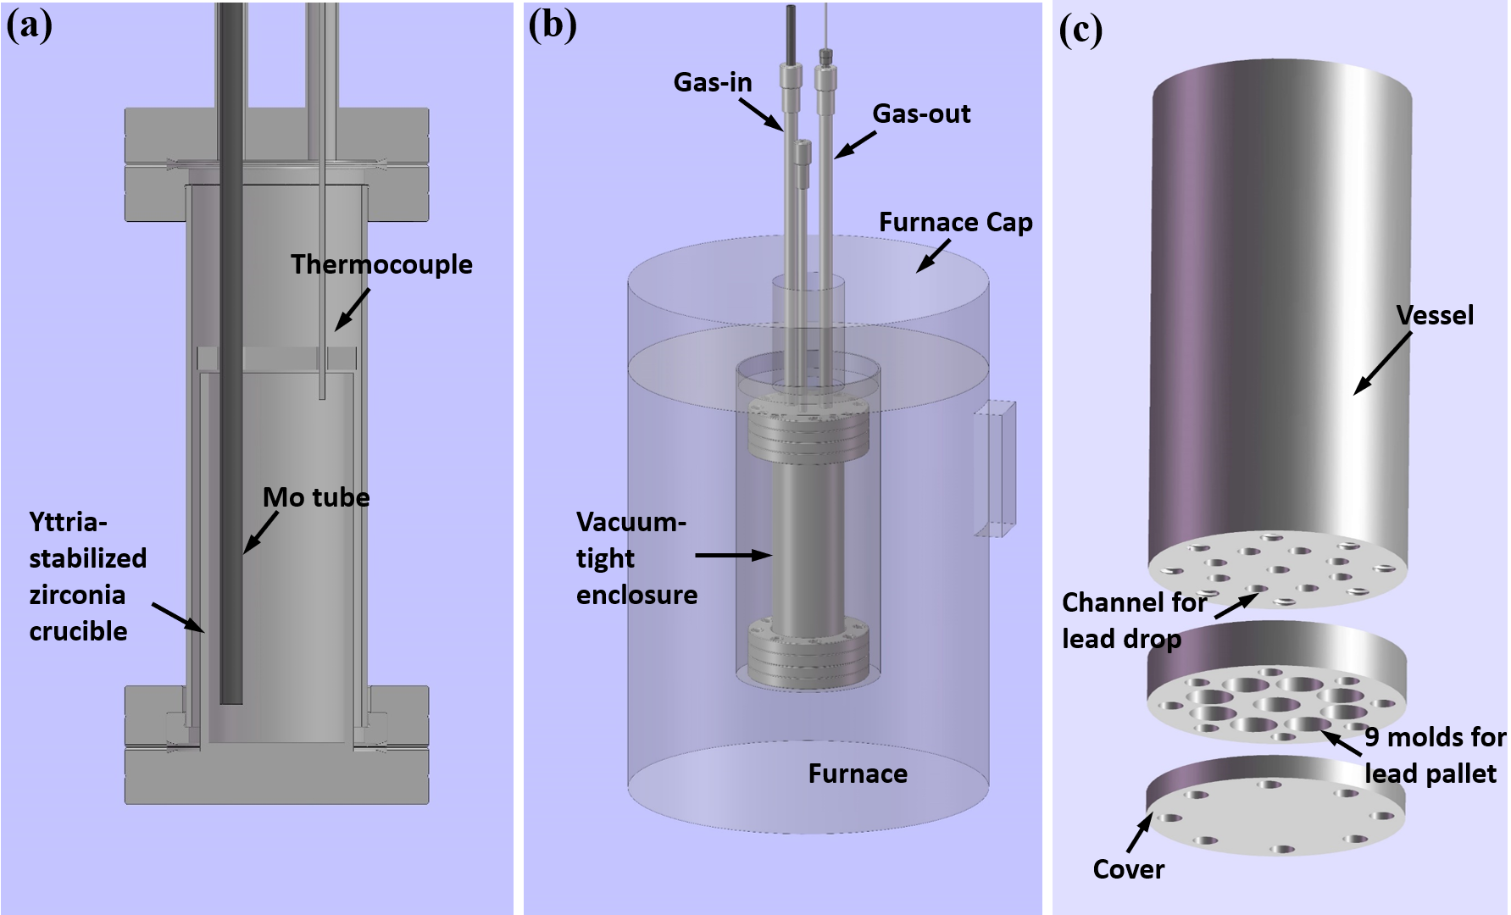

**Fig. 1.** Illustration of the lead purification and subsequent molding process. (a) Liquid lead alloy undergoing purification within a vacuum-tight enclosure, where a premixture of Ar gas with 5% hydrogen is introduced. (b) The vacuum-tight enclosure being heated in a furnace installed in the glovebox with a foreface cap. (c) Customized housing for the lead mold with 9 cylindrical spaces, each with a diameter of 12.7 mm and a height of 12.7 mm.

**2.1 Simultaneous radiation and corrosion experiments**

The experimental setup for simultaneous radiation and corrosion in liquid lead alloys was modified from our previous setup for molten salt [28]. As illustrated schematically in Fig. 2(a), the Pb-4wt.%Bi pellet was positioned in the corrosion cell, sealed by a 25 μm sample foil on the edge. The 3 MeV proton beam was introduced from the other side of the sample, using a Molybdenum aperture in front of the sample to confine the beam size to 5 mm in diameter. As shown in Fig. 2(b), SRIM calculations confirmed that the injected ion could penetrate throughout the sample and stop in the corrosion medium. Additionally, the Bragg peak of the damage profile was avoided in the sample, ensuring a relatively uniform distribution of damage throughout. Consequently, as Fig. 2(a) shows, on the sample, the central 5 mm region could be exposed to both radiation and corrosion, referred to as the RAC (radiation and corrosion) region, while the rest of the area was only exposed to liquid lead alloys without radiation, referred to as the CO (corrosion-only) region.

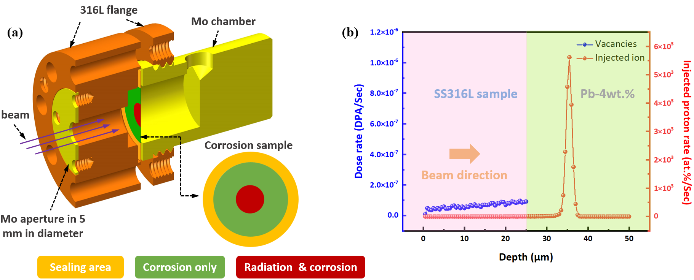

**Fig. 2.** Illustration of simultaneous radiation and corrosion of SS316L in liquid lead alloy. (a) The sample is exposed to the corrosion medium on one side, while proton beam, confined in spot size of 5mm in diameter by a Mo aperture, is introduced from the other side and penetrates throughout the sample. (b) SRIM calculation confirming the desired sample thickness within which fewer injected ions and uniform radiation damage remain.

To further achieve an ultra-low oxygen level during the simultaneous radiation and corrosion experiments, non-volatile oxygen getters obtained from SAES Getters USA, Inc., with a nominal composition of 70 wt% Zirconium, 24.6 wt% Vanadium, and 5.4 wt% Iron, were positioned in the front of sample with a hollow cylindrical cage. The assembly of the setup was completed in the glovebox to guarantee that the housing achieved a vacuum-tight seal. Subsequently, the assembly was transferred from the glovebox to the beamline, connecting to a 1.7 MeV Tandem accelerator via a Conflat flange. The interior of the housing was then evacuated using a vacuum pump to achieve a vacuum level around 10-6 Torr, read by an ion gauge. The temperature of the corrosion cell was gradually increased using a heater enclosing the corrosion cell. Initially, it was raised to 300°C, then to 500°C, and finally reached 675°C within approximately 1 hour in total. The final vacuum level at 675°C was measured to be around 10-6 Torr. The experiment ran for 4 hours and 8 hours, respectively. Radiation was unblocked once the temperature reached 675°C, with the beam having a current of approximately 80 nA striking the sample within a 5 mm-diameter circle.

**2.2 Characterization and statistical analysis**

After the simultaneous radiation and corrosion experiments, the corrosion cell was disassembled from the vacuum housing in the glovebox. As the sample foil was adhered to the solidified lead, the corrosion cell was reheated to around 400 °C for 40 minutes to remelt the lead, allowing the liquid lead to drop through a pre-drilled hole on the upper part of the cell. Following the removal of the sample, it was cut vertically, as depicted in Fig. 3(a), along the center to ensure that both RAC regions and CO regions were included. One part of the sample was used for cross-section analysis, while the other part was utilized for surface analysis. The cross sections both at RAC and CO regions were obtained with a JEOL SM-Z04004T argon ion polisher at a voltage of 6 kV and a beam current of around 140 μA, as shown in Fig. 3(a). Thus, a cross section with a width of 1 mm was prepared by polishing for approximately 1 hour and 10 minutes. Surface and cross-section images were captured using a Zeiss Gemini 450 field emission Scanning Electron Microscopy (SEM) in backscattering electron mode.

The SEM images from each cross-section region were captured at the same magnification and taken sequentially. This set of images was then stitched together in sequence using Fiji [29]. The stitched image then was straightened and cropped to correspond to a width of 1 mm. A binary process using the auto-threshold function in Fiji was applied, with the auto-threshold selected to achieve the best possible resolution of the bright contrast areas corresponding to lead penetration locations. To address the puddle-like empty spaces on the sample surface caused by the spallation of lead, artificial re-filling was performed. Additionally, contaminants and artifacts from cross-section polishing along the argon beam-facing side of the foil were removed by comparison with the original SEM images.

Subsequently, as illustrated in Fig. 3(b), each stitched image was segmented into over 20k pixel rows. For every row, the entire pixels with a gray value greater than 0 in the width of the row were counted, representing the whole thickness of the sample ($h_{t}$). The count of pixels from the beam-side surface to the point of the first lead penetration was also determined, referred to as the un-corroded depth ($h_{u}$). The corrosion depth ($h_{c}$) was then calculated as $h_{c}$ = $h_{t}$- $h_{u}$. The normalized corrosion depth was given by $d_{c}$ = $h_{c}$/ $h_{t}$. Consequently, the statistical analysis of corrosion information with depth followed the concept of a cumulative density function (CDF) [19].

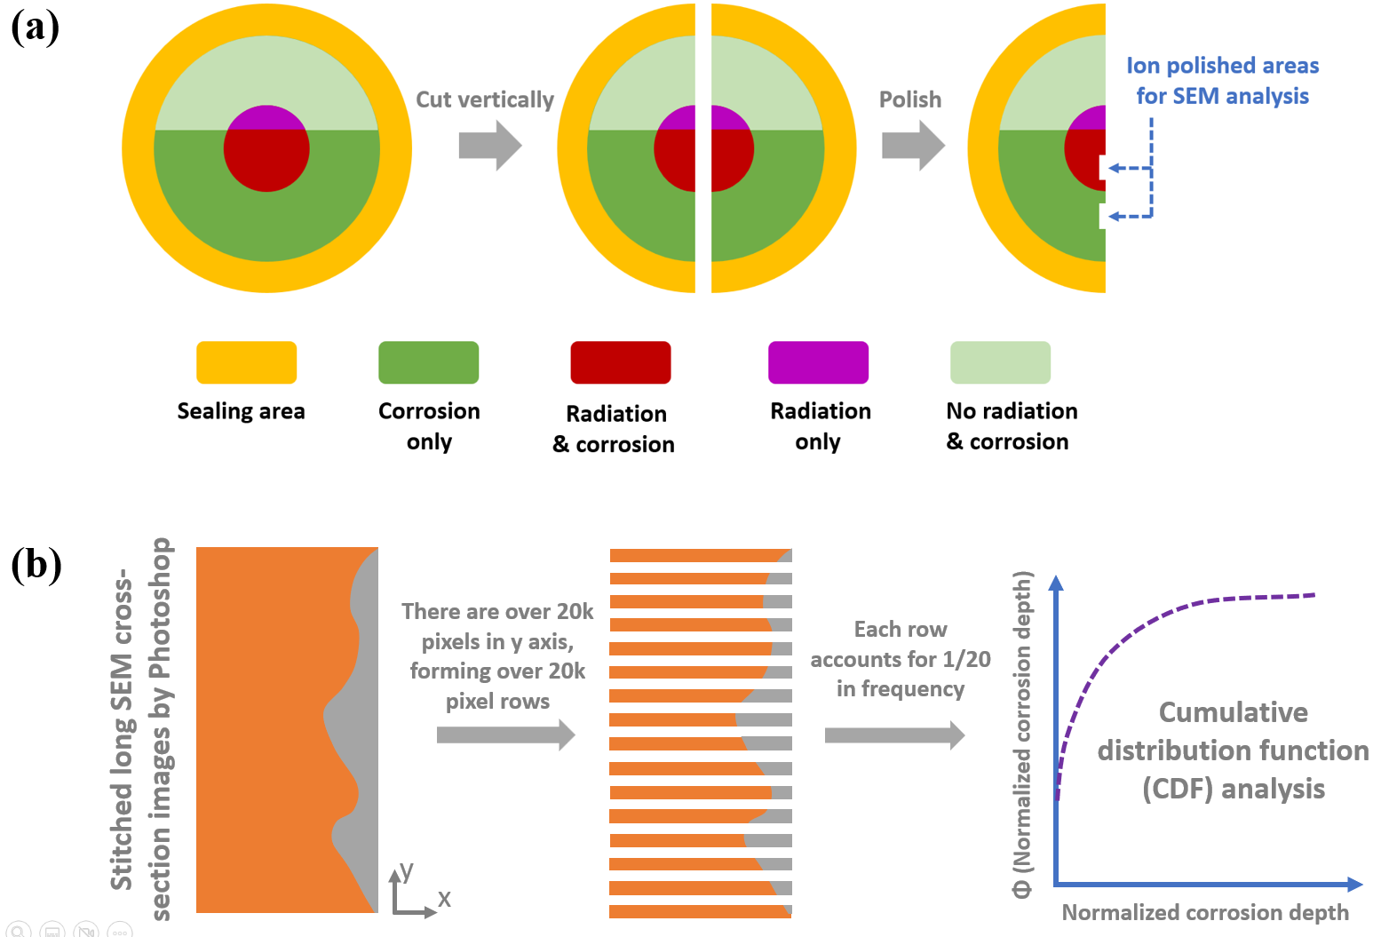

**Fig. 3.** Illustration of cross-section preparation after simultaneous radiation and corrosion (a) and corresponding statistical analysis of corrosion feature by borrowing the concept of cumulative distribution function (b).

Transmission Electron Microscopy (TEM) specimens were produced through Ga+ focused ion beam (FIB) lift-out from cross-section areas in both the RAC and CO regions. The beam energy utilized for thinning the sample gradually decreased from 30 to 2 keV. STEM-EDX characterization was performed using an FEI 2010F TEM at MIT nano center. The TEM operated in STEM mode with an electron beam energy of 300 keV.

**3. Results**

**3.1 Corrosion morphology and chemistry**

Fig. 4 displays the SEM surface morphology and corresponding Pb coverage on the surface after simultaneous radiation and corrosion experiments. In the zoom-out area depicted in Fig. 4(a), RAC regions exhibit a larger blocky Pb-4Bi coverage, as indicated by the brighter contrast of Pb in BSE mode for both 4h and 8h. In contrast, CO regions show less Pb coverage. This observation is further supported by SEM EDX elemental mapping of Pb, where the Pb intensity is much more pronounced in RAC regions compared to CO regions. Similar results are also evident in the zoom-in regions from Fig. 4(a), as depicted in Fig. 4(b), revealing a higher Pb attachment in RAC regions compared to CO regions. This observation indicates that radiation enhances the final Pb coverage at the surface, further suggesting that more Pb corrosion initiation could occur beneath the Pb coverage in RAC regions than in CO regions.

Beyond the lead coverage shown in Fig. 4, the shape of the solidified lead islands formed on the sample surface also can serve as an indicator of the enhancement in lead wetting by radiation. In Fig. 5(a) and (b), the lead islands in the CO region for 4-h experiment exhibit a spherical shape, while in the RAC region, the islands are flatter with a smaller contact angle respect to the sample surface. Additionally, in the RAC region of 4-hour experiment, the lead islands have several roots embedded in the sample surface, unlike in the CO region, where only a few roots are observed around the spherical lead islands. This enhancement in contact angle is more pronounced in the RAC region after 8 hours, using the CO region as a reference.

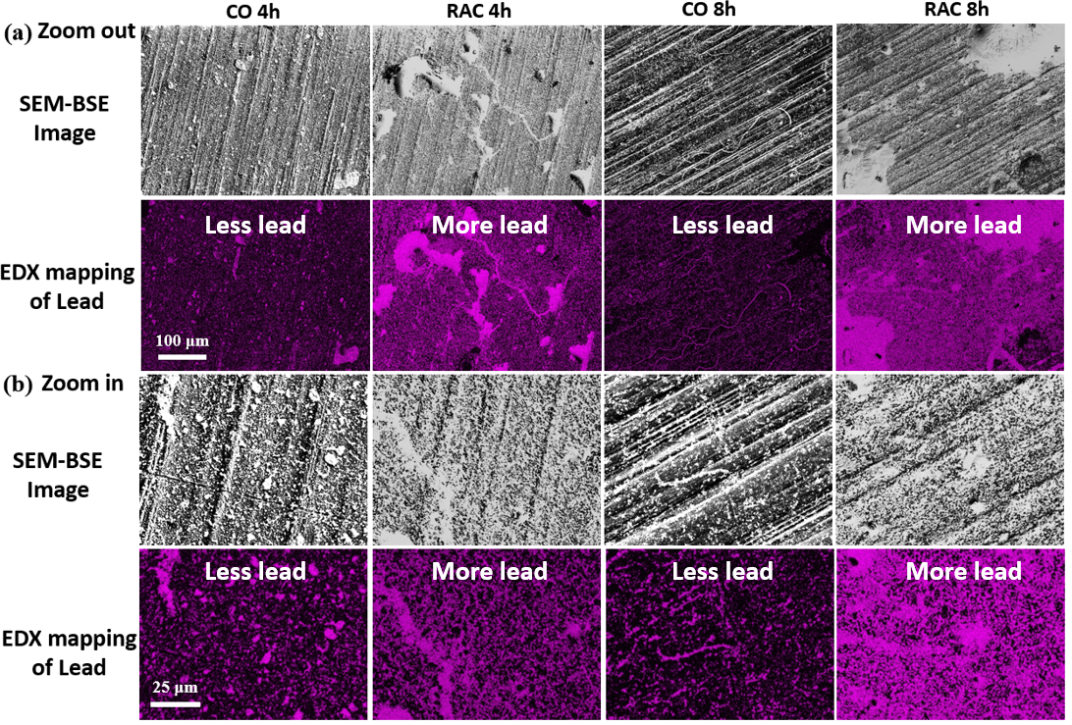

**Fig. 4.** Surface SEM morphology and EDX chemistry of Pb after simultaneous radiation and corrosion for 4 hours and 8 hours. (a) Zoomed-out view showing corrosion features over a large area, while (b) presents a zoomed-in view revealing localized chemistry.

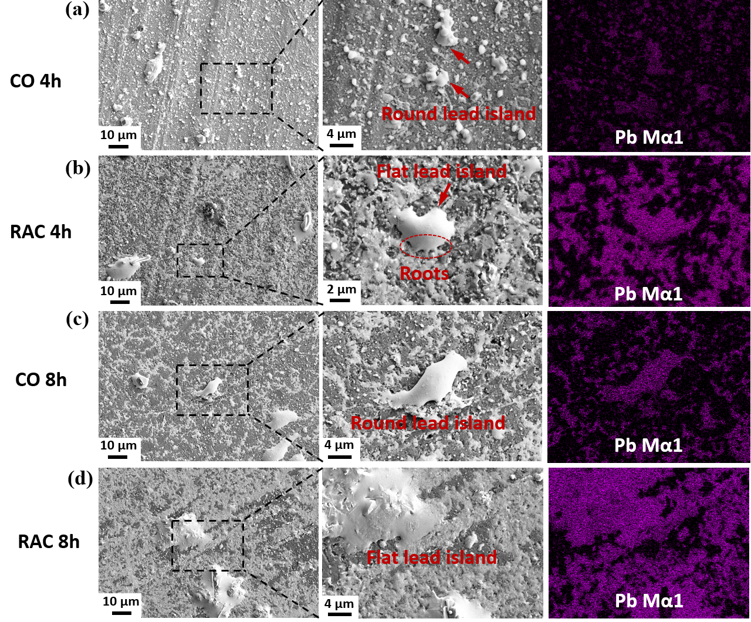

**Fig. 5.** SEM morphology and EDX chemistry of lead islands after simultaneous radiation and corrosion for 4 hours and 8 hours. (a) CO 4h. (b) RAC 4h. (c) CO 8h. (d) RAC 8h.

To observe the corrosion features beneath the Pb coverage on the surface, cross-section SEM images in BSE mode are presented in Fig. 6. Firstly, as shown in Fig. 6(a) and (b), more Pb can be observed near the surface in RAC regions than in CO regions, indicated by the presence of more white dots near the surface in RAC regions compared to CO regions. This supports the speculation from the surface results in Fig. 4 and 5 that radiation enhances Pb corrosion initiation. Secondly, while the difference in the deepest Pb penetration is insignificant in the 4-hour experiments, as indicated by the orange dashed lines, the RAC regions in the 8-hour experiments exhibit significantly deeper Pb penetration compared to the CO regions, as shown in Fig. 6(c) and (d). This suggests that the development of corrosion is faster in RAC regions than in CO regions. Therefore, by combining surface information with cross-section results, it can be concluded that radiation enhances both the Pb corrosion initiation and development. A statistical analysis will be illustrated in the following section.

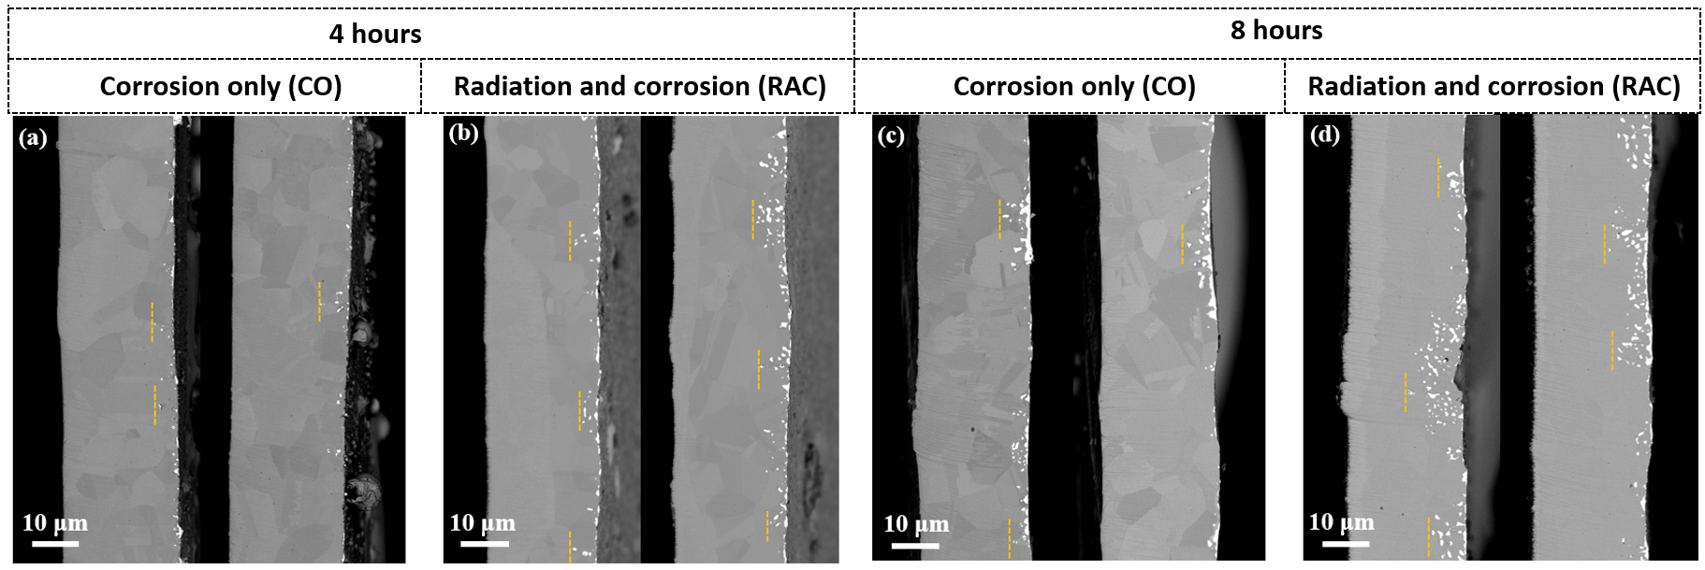

**Fig. 6.** Representative SEM images in backscattering mode presenting the corrosion features in cross-section after simultaneous radiation and corrosion for durations of 4 hours (a-b) and 8 hours (c-d), with the deepest lead penetrations highlighted by orange dashed lines.

**3.2 Image analysis**

To quantify radiation-affected Pb corrosion initiation near the surface, a subsurface area was defined, extending vertically from the surface down to a depth ranging from 3% to 10% of the total thickness of the cross-section. This range was selected to ensure that it represents Pb corrosion initiation near the surface. One demonstration of the subsurface area is illustrated in Fig. 6(a) by two green parallel lines using ImageJ. Within the subsurface area, the Pb area was determined by counting the pixels of Pb dots displayed in red in Fig. 6(a), while the total area of the subsurface area was measured by counting the total pixels within the subsurface area. The ratio of the Pb area (*Spb*) to the total area of the subsurface (*Stot*) was then used to quantify the Pb corrosion initiation as follows,

${Pb}_{initiation}= \frac{S_{Pb}}{S_{tot}}×100\%$ (3)

As shown in Fig. 7(b), an increase in Pb corrosion initiation is observed in RAC regions compared to CO regions across the subsurface range for both the 4-hour and 8-hour experiments. For instance, at a normalized corrosion depth of 0.05, Pb area accounts for only 5% of the total subsurface area in CO regions for the 4-hour experiment. In contrast, in RAC regions, Pb area comprises approximately 12% of the total subsurface area. The corresponding images in Fig. 7(c-d) further illustrate the difference in Pb corrosion initiation within the subsurface, where Pb penetration is more intense in RAC regions than in CO regions. A similar trend is observed in the 8-hour experiment, where Pb corrosion accounts for 14% of the subsurface area in CO regions and 18% in RAC regions. The corresponding representative cross-section images shown in Fig. 7(e-f), highlight the more extensive Pb corrosion in RAC regions compared to CO regions.

Supplementary Fig. 1 depicts the sensitivity study demonstrating how the subsurface lead ratio varies with different thresholds for the subsurface statistical analysis. The ratio presented in Fig. 6(b) was derived from the plateau curves with the same threshold for both CO and RAC regions at each time duration (4 hours and 8 hours). This approach ensures that the ratio is less dependent on the threshold, making it more representative.

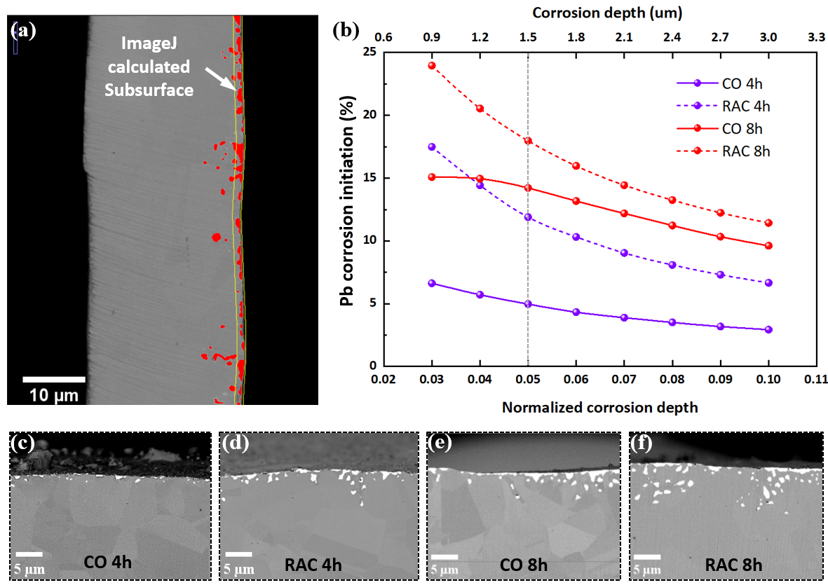

**Fig. 7.** Quantification of corrosion initiation by determining the Pb corrosion ratio in a subsurface area from surface to a depth ranging from 3% to 10% of the total thickness of the cross-section sample. (a) Demonstration showing the definition of the subsurface area and lead particles using Fiji. (b) Calculated subsurface Pb corrosion initiation for CO and RAC regions for 4 hours and 8 hours, accompanied by representative images (c) CO 4h, (b) RAC 4h, (c) CO 8h, (d) RAC 8h, accordingly.

Fig. 8 illustrates the cumulative distribution function (CDF) plot, depicting the cumulative distribution of lead penetration depth. As shown in Fig. 8(a) over 4-h duration, Pb penetration extended to approximately 0.36 of the normalized corrosion depth in the RAC region, contrasting with the CO region where Pb penetration only reached 0.3 of the normalized corrosion depth. This enhancement in the development of Pb penetration becomes more significant in 8h duration, where Pb penetrated nearly 0.5 of the normalized corrosion depth in RAC regions, while only around 0.3 was reached by Pb in CO regions. The zoomed-in view in Fig. 8(b), derived from Fig. 8(a), provides Pb corrosion information near surface. The lower value in the RAC region at the surface indicates that more Pb is attached at the surface in RAC regions compared to CO regions.

The corrosion development is also analyzed using two approaches: first, by averaging the 10% deepest Pb penetration in pixel rows from ImageJ processed data, as illustrated in Fig. 8(c); and second, by manually measuring the average of the 10 deepest Pb penetration clusters in a stitched long image, as shown in Fig. 8(d). Both figures demonstrate that the difference in Pb corrosion development between RAC and CO regions is less obvious within the 4-hour experiment, as the differences fall within the error bars. However, in the 8-hour experiment, the differences become more pronounced in both figures. This indicates that within the first 4 hours, radiation primarily affects Pb corrosion initiation, without significantly influencing its development. However, over a longer period, such as 8 hours, radiation not only enhances Pb corrosion initiation but also accelerates its development.

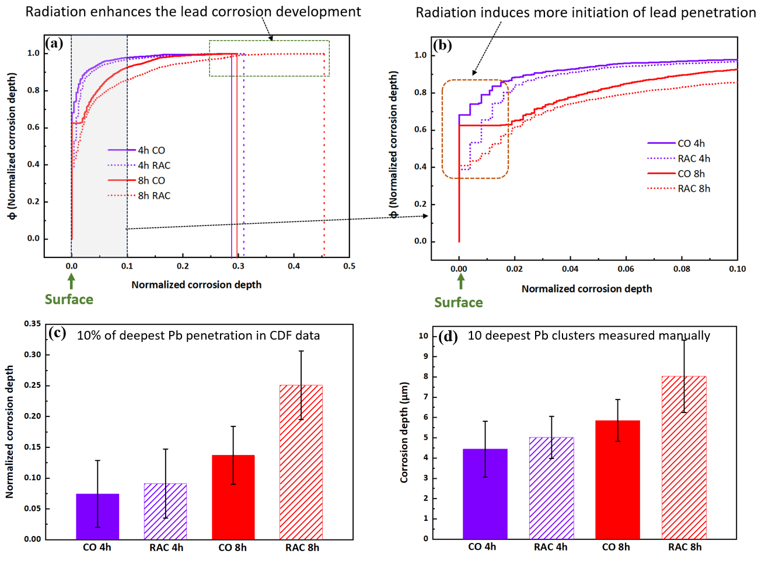

**Fig. 8.** Statistical analysis of corrosion features with corrosion depth using cumulative distribution function (CDF) and averaged corrosion depth. (a) Overall CDF displaying the cumulative distribution of normalized corrosion depth. (b) Zoomed-in view of near-surface information extracted from a normalized corrosion depth of 0.1 from (a). (c) Normalized corrosion depth in averaging 10% deepest Pb penetration in ImageJ processed data. (d) Corrosion depth in averaging 10 deepest Pb penetration measured manually.

**3.3 Microstructural elemental and phase analysis**

So far, both quantitative and qualitative observations have been utilized to distinguish between RAC and CO, revealing that radiation enhances both the initiation and development of Pb corrosion. To comprehend the radiation effects on corrosion, it is crucial to first understand the mechanism of corrosion itself. Therefore, this section will focus on elemental and phase changes during corrosion. Fig. 9 illustrates the local Pb corrosion features in both RAC and CO regions. It is evident that transgranular corrosion predominates in both regions, as indicated by the white Pb contrast within grains where representative grain boundaries (GBs) were shown in white arrows. Apart from Pb penetration, the darker regions surrounding the Pb penetration suggest elemental changes in these areas, as depicted in representative regions shown in SEM-BSE image in Fig. 9(b).

Fig. 10 displays STEM images alongside corresponding elemental mapping across the Pb regions, uncorroded substrate regions, and the intermediate regions between Pb and the substrate. Evidently, elemental depletion zones are present in both CO and RAC regions, situated in the middle of Pb regions and uncorroded regions. Within these depletion zones, Ni appears to leach out predominantly, as observed by minimal intensity in Ni EDX mapping, followed by Cr, while Fe exhibits minimal dissolution, within the depletion zone. This trend is consistent with data from the literature [2], where Ni has the highest solubility in pure Pb, followed by Cr, and Fe exhibits the smallest solubility among these three elements at 675°C.

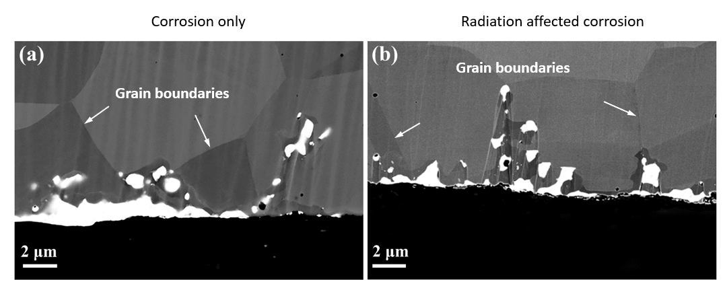

**Fig. 9.** Representative SEM images depicting localized Pb penetration after simultaneous radiation and corrosion for 4 hours in (a) CO and (b) RAC regions, with representative GBs marked by white arrows.

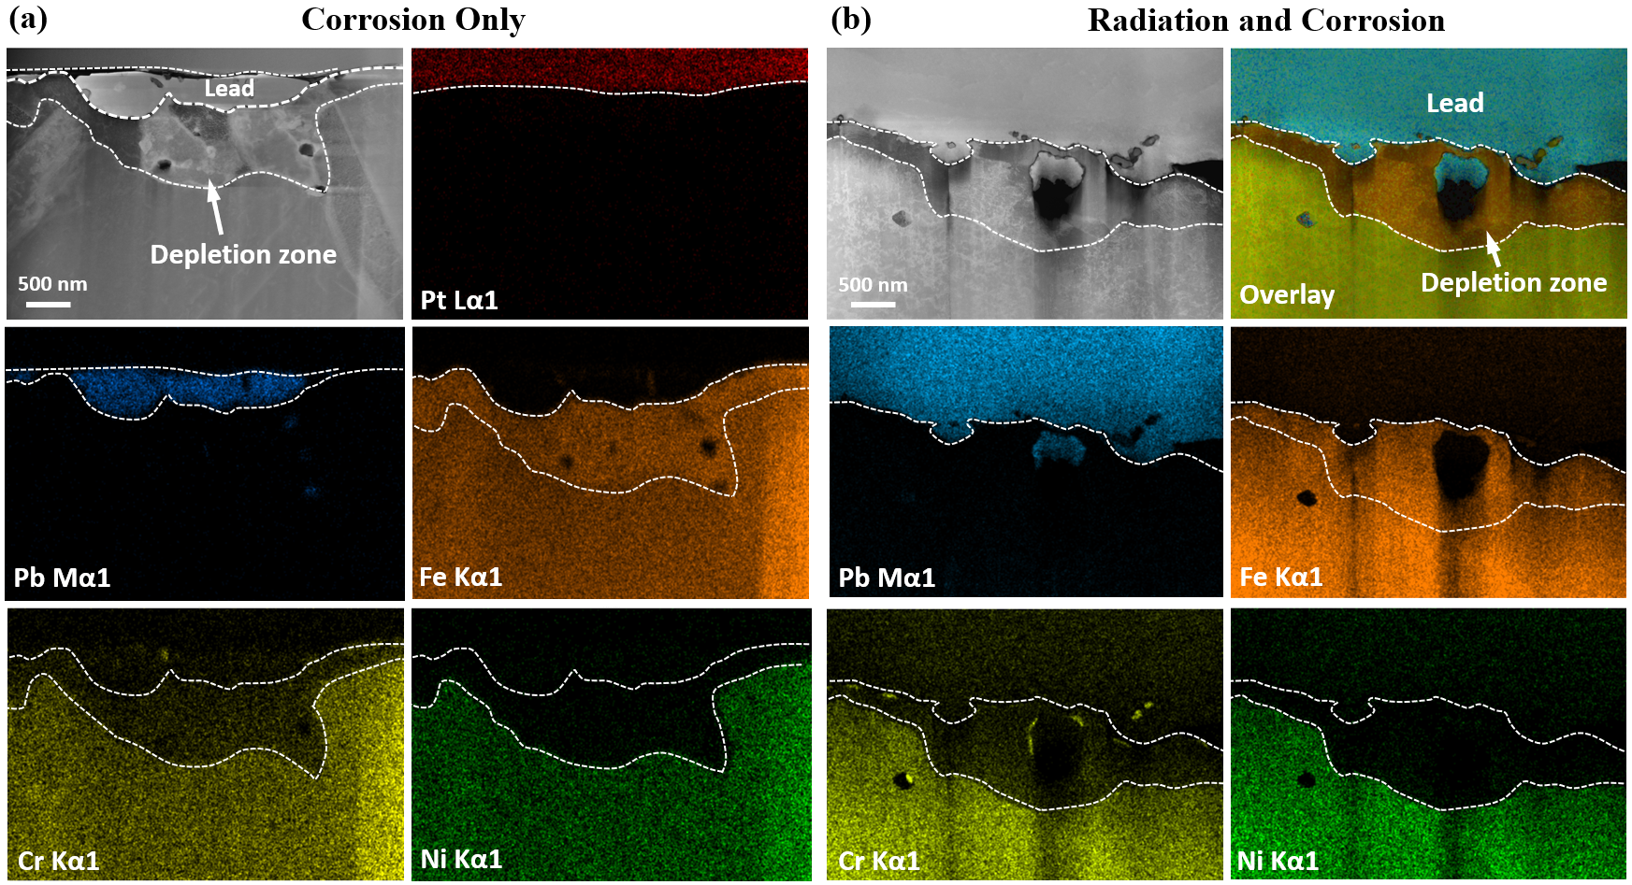

**Fig. 10.** STEM images and surrounding EDX mapping at the cross-section of CO (a) and RAC (b) regions after simultaneous radiation and corrosion for 4 hours, illustrating the selective elemental distribution across the interface between Pb and substrate.

Given that SS316L is an FCC structural-based alloy at 675°C due to the presence of Ni, the leaching of Ni could induce a phase transformation from FCC to BCC. To investigate this, TEM images and corresponding selective area diffraction patterns (SAEDs) are presented in Fig. 11. As depicted in Fig. 11(a), BCC SAEDs are evident in the depletion zone right beneath the Pb region, while FCC SAEDs are observed in the substrate region, far from the depletion zones in CO. Similar results are observed in RAC, where different crystal structures are evident in the depletion zone and substrate.

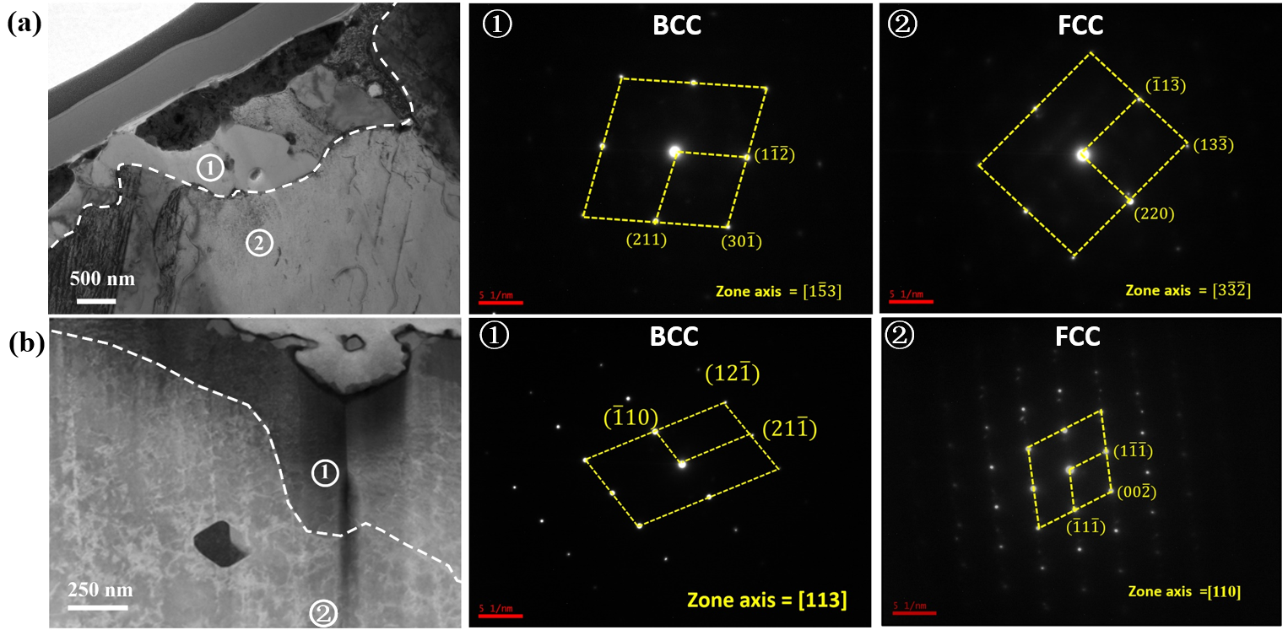

**Fig. 11.** TEM images along with selective area diffraction patterns (SAEDs) in the depletion zone and substrate for (a) CO region and (b) RAC region, showing a BCC structure in the depletion zone and an FCC structure beneath the depletion zone in the substrate.

As the introduction of phase transformation could influence the corrosion development of Pb, understanding the elemental diffusion pathway between the fresh substrate and Pb region is crucial. Fig. 12 presents the weight percentage profile of Ni from the fresh substrate across the phase boundary (PB) to the depletion zone. In RAC regions, as shown in Fig. 12(b), the weight percentage of Ni is reduced from 10% at the fresh substrate to almost 0% at the depletion zone. A similar trend is observed in Cr, where it has a weight concentration of 16% at the fresh substrate, reduced to 7% at the depletion zone. In contrast, Fe shows an enrichment in concentration from 70% weight percentage to almost 90% weight percentage. A similar trend is also shown in CO regions in Fig. 12(a). Given that Ni is the key element that can induce phase transformation, the 0% concentration of Ni at the depletion zone suggests that the outward diffusion of Ni from the fresh substrate mainly does not occur through the depletion zone. Instead, the dominant transport of Ni is likely along the PB. Additionally, as shown in Fig. 12, since no Pb can be detected in the depletion zone, it can be suggested that Pb might migrate inward along the PB. A detailed description of the mechanism of corrosion development will be discussed in the discussion section.

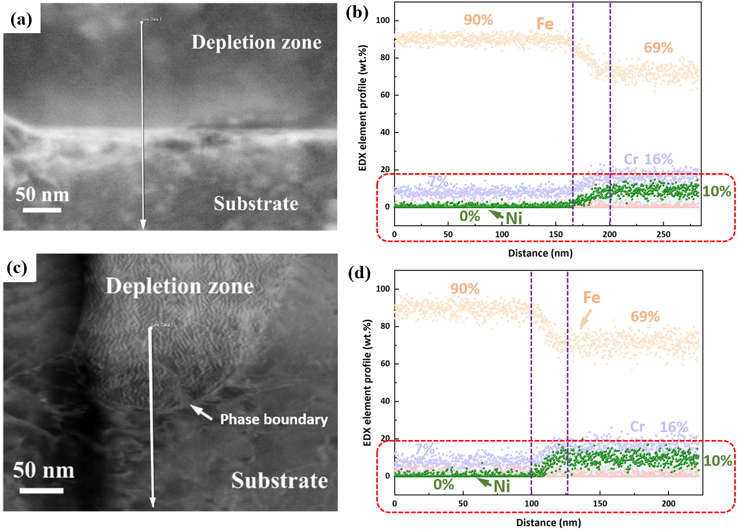

**Fig. 12.** STEM images combined with EDX linescan show the elemental profile within the depletion zone and beneath the depletion zone in the substrate, revealing that nearly zero Ni can be detected in the depletion zone for both CO region (a-b) and RAC region (c-d).

**3.4 Radiation affected microstructure**

To investigate how radiation affects the corrosion mechanism of SS316L in Pb-4Bi, TEM is utilized to examine the microstructure around the depletion zone in CO and RAC regions. The bright-field (BF) image in Fig. 13(b), serving as a zoomed-in view indicated by the orange dash line square area from Fig. 13(a), reveals the presence of dislocation networks and loop clusters, with representatives indicated by white arrows, beneath phase boundaries in RAC regions. Additionally, it can be observed that some loops intersect with phase boundaries. This observation is further supported by the dark-field (DF) image in Fig. 13(c), where dislocations and loops are highlighted by a brighter contrast. In contrast, a cleaner microstructure with few dislocations and loops is evident beneath the depletion zone in the CO region, as shown in Fig. 13(d)-(e). This difference in microstructure, influenced by radiation, may impact the corrosion mechanism by influencing the migration of Ni in the substrate. It is essential to note that numerous point defects as interstitials and vacancies are created during radiation, but they are beyond the resolution of TEM in this work. A detailed discussion will be provided in the discussion section.

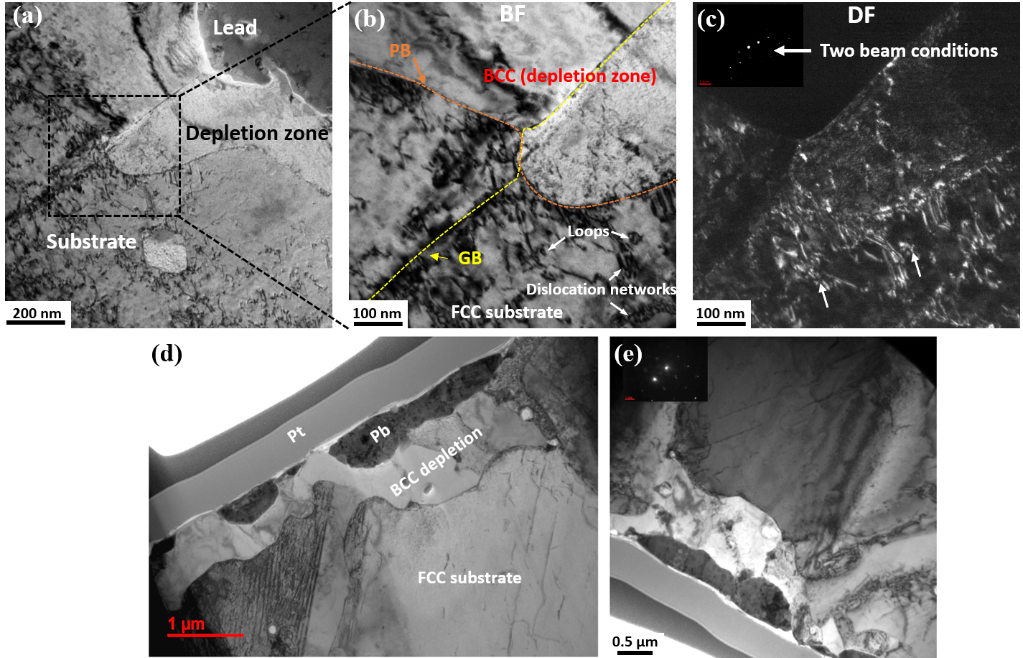

**Fig. 13.** TEM images indicating microstructure of RAC (a-c) and CO (d-e) regions after simultaneous radiation and corrosion, showing the dislocation networks and loops beneath the phase boundary.

**4. Discussion**

**4.1** **Lacking of intergranular attacking**

Before discussing how radiation affects the corrosion of SS316L in liquid lead, it is crucial to discuss the corrosion mechanism itself.

Firstly, as observed in Fig. 9, lead penetration occurs preferentially in a transgranular manner rather than intergranularly. This behavior could be attributed to the ferritization at GBs, as illustrated in the EBSD phase image in Fig. 14(b), where the BCC phase aligns with the GBs, while the FCC phase constitutes the substrate.

This ferritization at GBs could be induced by the selective leaching of Ni at the solid-liquid interface when exposed to liquid Pb-4Bi. Ni, having a higher solubility in Pb-4Bi compared to Cr and Fe, is preferentially dissolved from the interface into the liquid metal. This results in a concentration gradient of Ni at solid-liquid interface that drives the diffusion of Ni from regions further away from the interface toward the interface.. While compared to bulk diffusion, the GBs diffusion would be more viable due to the lower energy barrier at GBs than in bulk. This far away ferritization at GBs can be supported by the presence of ferritization at GBs far from the lead-corroded side, as seen in Fig. 14(h), which is located nearly 20 μm away from the lead-corroded region. The energy barrier-dependent diffusion process can be described by the following equation:

$D_{V}=D_{0}e^{\left(\frac{-E_{A}}{k_{B}T}\right)}$ (4)

where *DV*  is diffusivity, and *D0* diffusion coefficient, *EA* is diffusion energy barrier and *kB​T* is the thermal energy. In FCC metals, the diffusivity at GBs is approximately 10−16 m²/s at a homologous temperature (*Tm/T*) of around 2, which is corresponding to 675°C for SS316L. In contrast, the bulk diffusivity at the same temperature is approximately 10−25 m²/s [30]. This nearly nine orders of magnitude higher diffusivity at GBs allows for Ni depletion at the GBs at 675°C, leading to long-range ferritization along the GBs. This ferritization at the GBs could render them inert to attack by liquid metal due to less Ni content at GBs. In contrast, liquid metal preferentially attacks the bulk, resulting in transgranular corrosion.

(Add)

**4.2** **Transgranular attacking**

Transition

Given that ferritization of the local substrate could be more resistant to lead, the continuity of this ferritization plays a crucial role in preventing deeper penetration by lead. As illustrated in Fig. 14(b), the Pb region on the left, marked by the white arrow, is enclosed by a continuous ferritized substrate. In contrast, the Pb region on the right is exposed to fresh substrate without ferritization beneath the lead, indicating a discontinuous ferritization around the right Pb region. This continuous ferritization between the liquid lead and the fresh substrate could act as a passivation layer, mitigating further lead infiltration into the fresh substrate and reducing the diffusion of Ni outward into the liquid lead. This is further supported by a larger-scale view of the sample surface post-exposure to liquid lead, as illustrated in Fig. 14(h). The image reveals that there is no significant lead penetration beneath the region covered by continuous ferritization, as marked by the white dashed rectangular outline. However, beneath the areas with discontinuous ferritization, deeper lead penetration into the substrate is evident, highlighted by the white dashed square in Fig. 14(g).

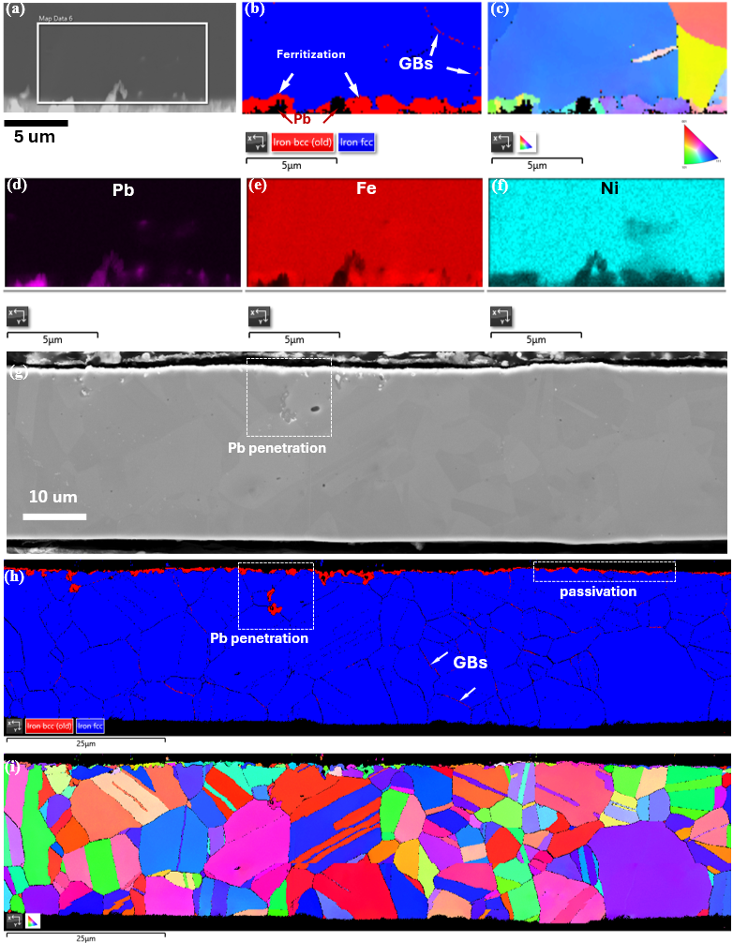

**Fig. 14.** EBSD results showing the phase mapping and crystal orientation after exposure to liquid Pb-4Bi at 675°C. (a) BSE image. (b) and (g) Phase mapping. (c) and (h) Crystal orientation. (d)-(f) EDX mapping.

The lead attack to a bulk could be concluded in the schematics in Fig. 15. By exposing to liquid lead at 675°C, Ni predominantly dissolves in liquid lead, followed by Cr, as shown in the STEM-EDX mapping in Fig. 10, where Ni is barely detected, leading to Ni depletion zone. This could be attributed to Ni having three orders of magnitude of solubility in liquid lead compared to Cr and Fe at 675°C [2].

The agglomeration of vacancies created by Ni dissolution likely enables the inward flow of liquid lead. The exact atomic process of lead infiltration is unclear. The channels for the lead flow are likely percolated to the surface of the foil to allow the flow of liquid lead into the bulk. This could be a similar process as previous observation of molten salt causing wormhole-like corrosion tunnels [31] . However, the possibility of lead infiltration as single/multiple atomic layers along the phase boundary as the initiation of the lead penetration is not ruled out. Previous observation was made in liquid bismuth infiltration of the GBs [32] ]. This opposite-direction transport is schematically illustrated in Fig. 15(a), where the purple arrows denote the outward Ni-dominated elements diffusion, while the orange arrows represent the inward migration of liquid lead. The leaching of Ni could induce a phase transformation (ferritization) in the areas exposed to lead, transitioning from FCC to BCC and creating a phase boundary (PB) between the BCC-based depletion zone and FCC substrate as evident in Fig. 11. The schematic representation of the phase transformation is depicted by the light green area in Fig. 15(b). This PB is considered to play a crucial role in the development of lead penetration in areas where ferritization does not fully enclose the lead. The absence of Ni in the ferritized region, as indicated by the STEM EDX-line scanning results showing nearly zero weight percent of Ni in the depletion zone (Fig. 11), suggests that further corrosion is driven by the inward flow of Pb and the outward diffusion of Ni from the substrate along the PB, rather than through the depletion zone. As a 2D defect, the PB facilitates higher diffusivity of the elements compared to bulk diffusion [30]. The opposite-direction transport of Ni and lead along the PB is schematically depicted by multiple purple arrows and orange arrows in Fig.15, respectively.

As Ni diffuses outward along the PB, additional Ni from the substrate near the PB could be induced to migrate towards the boundary, driven by the Ni concentration gradient. The leaching of Ni in the substrate adjacent to the PB would subsequently nucleating a new phase transformation from FCC to BCC. Once this new phase forms, the outward diffusion of Ni would primarily be governed by the newly-formed PB, while diffusion through the phase transformation zone would be relatively weakened, leading to a repetition of the process depicted in Fig. 15(c).

However, this cyclic process would cease when the ferritization fully encloses the liquid lead, blocking its pathway to be in direct contact with the fresh substrate. The same applies to the outward diffusion of Ni from the fresh substrate. Consequently, the liquid metal becomes "inactive" in its penetration. The SEM results in Fig. 8(b) reflect this situation in a 2D view, where a portion of Pb is entirely enclosed by the depletion zone, indicated by a darker contrast compared to the fresh substrate.

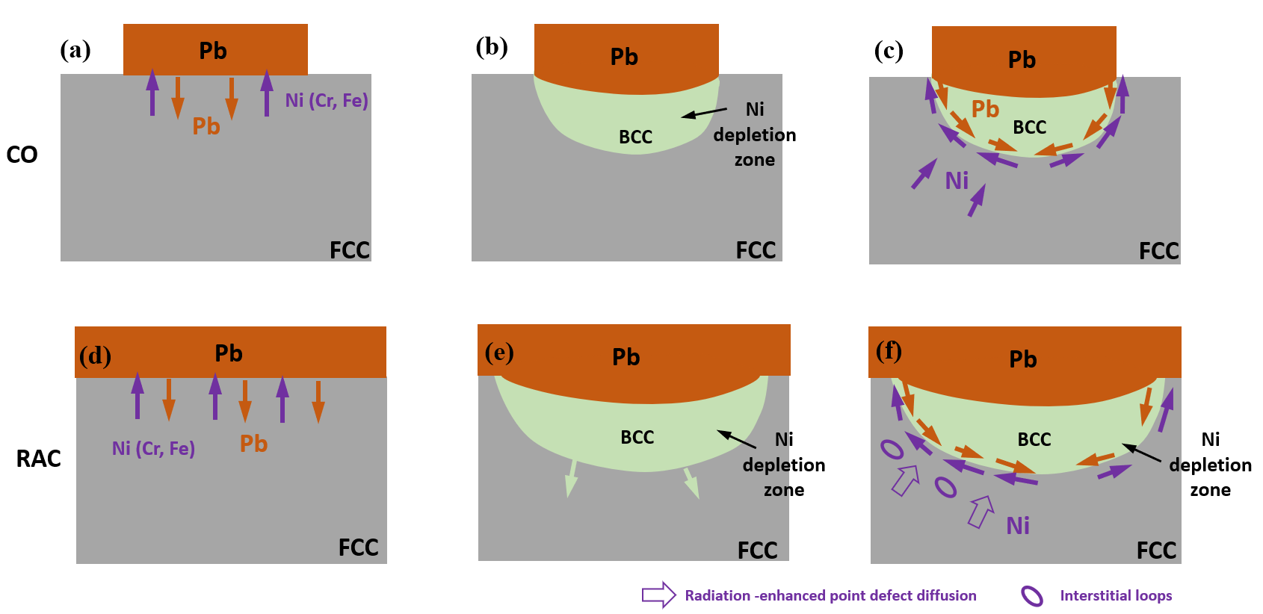

**Fig. 15.** Illustration of the mechanism of Pb corrosion and the influence of radiation on it.

**4.2 Radiation affected corrosion**

The influence of radiation on corrosion of SS316L might be divided into its effect on the initiation and development of Pb penetration.

Firstly, the cross-sectional images in Fig. 6, combined with the statistical analysis in Fig. 7, confirm that the initiation of Pb penetration is enhanced in RAC regions compared to CO regions in both the 4-hour and 8-hour experiments. This enhancement can be attributed to the increased lead wetting on the sample surface when radiation is applied. As shown in Fig. 4, SEM-EDX mapping of Pb indicates a higher concentration of Pb in RAC regions compared to CO regions. Additionally, Fig. 5 reveals that Pb islands formed on the surface have better contact with the sample in RAC regions than in CO regions, with the Pb islands in RAC regions being flatter in shape, while those in CO regions are more spherical. So, the enhancement of lead wetting on the sample surface likely can be described by Young's relation.

$γ_{lv}cosθ+γ_{ls}= γ_{sv}$ (5)

where γlv​ is the liquid surface energy, γls is the interfacial energy between the liquid lead and the solid sample, and γsv​ is the surface energy of the solid sample. It is reported that radiation can induce sputtering and swelling on the surface, which results in an increase the surface energy from the increased roughness [33]. In contrast, radiation is supposed to have less impact on γlv​ and γls​, given that lead remains in its liquid state. Therefore, the increase in surface energy γsv​ can enhance the wetting of lead.

In addition to enhancing surface energy, the improvement in liquid metal wetting by radiation could also be attributed to several factors. Firstly, radiation-induced surface defects may enhance the surface diffusion of Ni, leading to accelerated kinetics of Ni dissolution. This, in turn, facilitates liquid metal infiltration. Secondly, radiation could homogenize surface defects such as impurities and cavities, reducing variations in liquid Pb attachment preferences and resulting in more uniform lead coverage. Thirdly, radiation might sputter off surface impurities, including pre-existing oxide scales, thereby improving the contact between the liquid metal and the alloy surface [34].

This radiation-induced wettability enhancement has been reported in studies where ionizing radiation, such as gamma irradiation, was shown to improve the surface wettability of materials like SS316 and Zircaloy-4 when exposed to two-phase fluids [35]. However, it is uncertain whether radiation directly alters wetting, thereby leading to an increased initiation of lead penetration, or if radiation primarily affects the corrosion process without significantly changing the wetting behavior, which then results in increased initiation of lead penetration and subsequently better wetting. Nonetheless, a higher lead coverage is observed under radiation, suggesting a correlation between radiation and wetting. A detailed study should be conducted in future work to investigate these speculations.

Once lead corrosion is initiated, radiation would affect its development. In metal bulk sample, under point defect kinetics model, radiation damage cascades produce numerous interstitials in equal proportion to vacancies in the grains at beginning. But interstitials are much more mobile, compared to vacancies, resulting in their faster diffusion towards to surfaces or PBs as sinks [36]. Consequently, the total diffusivity of the metal could be enhanced by [37]:

$D_{\text{rad}}=D_{V}X_{V}+D_{i}X_{i}$ (6)

Where $D_{\text{rad}}$ is total diffusion coefficient; $D_{V}$ and $D_{i}$ are the vacancy and interstitial self-diffusivity, respectively, while $X_{V}$ and $X_{i}$ are the site concentrations of vacancies and interstitials.

The enhancement of diffusion by radiation could firstly facilitate the occurrence of phase transformation by enhancing the leaching of Ni into interface between substrate and liquid lead, as schematically shown in Fig. 15 (d), where a larger depletion zone is formed.

Once the PB between the phase change zone and substrate is created, radiation could enhance the diffusion of Ni by creating interstitials and Ni interstitials migrating from the substrate bulk to the PBs.

It’s important to note that radiation enhances diffusion of all elements from their non-irradiation state, including Ni. Radiation also creates vacancies that enhances diffusion, but interstitial mechanism can be considered inactive without radiation due to the low number of thermally activated interstitials.

When

At a homologous temperature of 0.5, corresponding to 675C, this radiation affects process could be formulated by:

This can be written in the following equations,

 (7)

 (8)



Where, $K_{0}$ is the damage production rate constant. $K_{iv}$ and $K_{is}$ are interstitial rate constants for recombination and absorption by sinks, respectively. $C_{i,Ni}$ is Ni interstitial concentration created during radiation in the bulk, and $C_{s}$ is sink (PB) concentration. Additionally, we have neglected the spatial dependence in equation (2).

In addition to the radiation-enhanced Ni diffusion described the point defects kinetics model, Ni could also potentially diffuse via dislocation loops. As observed in the TEM results presented in Fig. 13(a)-(c), numerous dislocation networks and loops are evident beneath the PB, with some intersecting with the PB in RAC regions, while few are observed in CO regions. One-dimensional diffusion of interstitial loops has been proved in both experimental observation and MD simulation in metals [38], with the diffusivity decreasing as the size of the interstitial loops increases [39, 40]. Therefore, under the influence of radiation-enhanced diffusion of point defects, coupled with the one-dimensional diffusion of interstitial loops, the migration of Ni from the bulk towards the phase boundary would likely be accelerated by radiation, thereby facilitating the formation of PB. Consequently, the corrosion development under radiation would exhibit a self-accelerated process, as the Ni source continually precedes the PB. This radiation-affected corrosion development is schematically shown in Fig. 15(f), where radiation enhanced diffusion in point defects and interstitial loops are represented by wider arrows and circles, respectively. It is important to note that while radiation enhances the kinetics of the process, it does not fundamentally alter the corrosion mechanism itself.

**5. Conclusion**

In this study, the synergistic effects of radiation and corrosion on SS316L in liquid lead with 4% bismuth were investigated at 675°C under a 3MeV proton beam. Both qualitative and quantitative analyses were employed to differentiate radiation and corrosion (RAC) regions and corrosion only (CO) regions. Additionally, the corrosion mechanism of SS316, in conjunction with the radiation effects on both corrosion initiation and growth, was discussed. The following summarizes the outcomes of this work.

1. Radiation was found to enhance both the initiation and development of corrosion in liquid lead on SS316L. This was evidenced by an increase in the intensity of Pb penetration near the surface and deeper penetration of Pb in RAC regions compared to CO regions.
2. The predominant dissolution of Ni, with lower solubility observed for Fe and Cr, in liquid lead led to the formation of a depletion zone beneath the lead surface. This depletion zone followingly triggered a phase transformation from FCC to BCC in the depletion zone.
3. The enhancement of corrosion initiation in RAC regions could be attributed to an increase in lead wetting on the surface due to radiation. Furthermore, radiation appeared to facilitate corrosion development in RAC regions by enhancing Ni diffusion from the substrate toward the PB via point defects and 1D interstitial loops movement, thereby promoting corrosion progression.

Highlights:

* We successfully built the setup for simultaneous radiation and corrosion testing in lead-based liquid alloys.
* We statistically quantify both initiation and growth of Pb-4Bi penetration with and without irradiation.
* Radiation could enhance initiation and development of Pb-4Bi penetration.
* We proposed a growth model of Pb-4Bi corrosion in grain of SS316L, and how radiation affects it.
* The initiation and growth enhancement by radiation is likely attributed to radiation enhanced lead wetting and diffusion of point defects and dislocation loops, respectively.

**References**

[1] J.S. Zhang, N. Li, Review of the studies on fundamental issues in LBE corrosion, J Nucl Mater 373(1-3) (2008) 351-377.

[2] X. Gong, M.P. Short, T. Auger, E. Charalampopoulou, K. Lambrinou, Environmental degradation of structural materials in liquid lead-and lead-bismuth eutectic-cooled reactors, Prog Mater Sci 126 (2022).

[3] J.S. Zhang, A review of steel corrosion by liquid lead and lead-bismuth, Corros Sci 51(6) (2009) 1207-1227.

[4] W. Cairang, S.Q. Ma, X. Gong, Y. Zeng, H.J. Yang, D.Z. Xue, Y.B. Qin, X.D. Ding, J. Sun, Oxidation mechanism of refractory Molybdenum exposed to oxygen-saturated lead-bismuth eutectic at 600 °C, Corros Sci 179 (2021).

[5] O. Chopra, D. Smith, Corrosion of Ferrous-Alloys in Eutectic Lead-Lithium Environment, J Nucl Mater 123(1-3) (1984) 1219-1224.

[6] E.M. Valls, L.A. Sedano, L. Batet, I. Ricapito, A. Aiello, O. Gastaldi, F. Gabriel, Lead-lithium eutectic material database for nuclear fusion technology, J Nucl Mater 376(3) (2008) 353-357.

[7] X. Gong, P. Marmy, L. Qin, B. Verlinden, M. Wevers, M. Seefeldt, Temperature dependence of liquid metal embrittlement susceptibility of a modified 9Cr-1Mo steel under low cycle fatigue in lead-bismuth eutectic at 160-450 °C, J Nucl Mater 468 (2016) 289-298.

[8] X. Gong, R. Li, M.Z. Sun, Q.S. Ren, T. Liu, M.P. Short, Opportunities for the LWR ATF materials development program to contribute to the LBE-cooled ADS materials qualification program, J Nucl Mater 482 (2016) 218-228.

[9] G.S. Was, D. Petti, S. Ukai, S. Zinkle, Materials for future nuclear energy systems, J Nucl Mater 527 (2019).

[10] N. Okubo, Y. Fujimura, M. Tomobe, Effect of Irradiation on Corrosion Behavior of 316L Steel in Lead-Bismuth Eutectic with Different Oxygen Concentrations, Quantum Beam Sci 5(3) (2021).

[11] S. Qvist, A.M. Bolind, P. Hosemann, Y.Q. Wang, J. Tesmer, M.S. De Caro, M. Bourke, Capability demonstration of simultaneous proton beam irradiation during exposure to molten lead-bismuth eutectic for HT9 steel, Nucl Instrum Meth A 698 (2013) 98-105.

[12] P. Hosemann, R.R. Greco, I. Usov, Y. Wang, S.A. Maloy, N. Li, The design, setup and operational testing of the irradiation and corrosion experiment (ICE), J Nucl Mater 376(3) (2008) 392-395.

[13] Q.S. Chen, H. Liu, J. Yang, C.D. Zhu, W. Zhang, Y.L. Zhong, Q.Y. Li, J.G. Deng, N. Liu, J.J. Yang, Microstructure evolution and lead-bismuth eutectic corrosion behavior of 11Cr1Si ferritic/martensitic steel after proton irradiation, J Nucl Mater 566 (2022).

[14] S.K. Wang, S.H. Zhang, J.Y. Xie, X.Y. Feng, M. Song, G.S. Was, W.J. Kuang, Clarifying the mitigation effect of proton irradiation on the intergranular oxidation of 316L stainless steel in high temperature water, Acta Mater 241 (2022).

[15] P. Wang, G.S. Was, Oxidation of Zircaloy-4 during in situ proton irradiation and corrosion in PWR primary water, J Mater Res 30(9) (2015) 1335-1348.

[16] M. Wang, M. Song, C.R. Lear, G.S. Was, Irradiation assisted stress corrosion cracking of commercial and advanced alloys for light water reactor core internals, J Nucl Mater 515 (2019) 52-70.

[17] Z.J. Jiao, G. Was, Oxidation of a Proton-Irradiated 316 Stainless Steel in Simulated Bwr Nwc Environment, 15th International Conference on Environmental Degradation of Materials in Nuclear Power Systems-Water Reactors (2011) 1329-1338.

[18] Z.B. Zhu, H.F. Huang, G.H. Lei, Y.P. Wu, C.L. Ren, A.W. Liu, Z.Y. Zhu, Synergistic effect of irradiation and molten salt corrosion: Acceleration or deceleration?, Corros Sci 185 (2021).

[19] W.Y. Zhou, Y. Yang, G.Q. Zheng, K.B. Woller, P.W. Stahle, A.M. Minor, M.P. Short, Proton irradiation-decelerated intergranular corrosion of Ni-Cr alloys in molten salt, Nat Commun 11(1) (2020).

[20] N. AlMousa, W.Y. Zhou, K.B. Woller, M.P. Short, Effects of simultaneous proton irradiation on the corrosion of commercial alloys in molten fluoride salt, Corros Sci 217 (2023).

[21] C.F. Yao, H.P. Zhang, H.L. Chang, Y.B. Sheng, T.L. Shen, Y.B. Zhu, L.L. Pang, M.H. Cui, K.F. Wei, Y.C. Xu, D. Wang, C. Liu, Z.W. Ma, L. Zhao, W. Yan, T.J. Peng, J.Y. Li, C.P. Qin, Z.G. Wang, Structure of surface oxides on martensitic steel under simultaneous ion irradiation and molten LBE corrosion, Corros Sci 195 (2022).

[22] J. Yang, F.F. Zhang, Q.S. Chen, W. Zhang, C.D. Zhu, J.G. Deng, Y.L. Zhong, J.L. Liao, Y.Y. Yang, N. Liu, J.J. Yang, Effect of Au-ions irradiation on mechanical and LBE corrosion properties of amorphous AlCrFeMoTi HEA coating: Enhanced or deteriorated?, Corros Sci 192 (2021).

[23] D. Frazer, S. Qvist, S. Parker, D.L. Krumwiede, M. Caro, J. Tesmer, S.A. Maloy, Y.Q. Wang, P. Hosemann, Degradation of HT9 under simultaneous ion beam irradiation and liquid metal corrosion, J Nucl Mater 479 (2016) 382-389.

[24] Q.S. Chen, Y.X. Chen, F.F. Zhang, J. Yang, C.D. Zhu, W. Zhang, H. Liu, Y.L. Zhong, J.G. Deng, Q.Y. Li, N. Liu, J.J. Yang, proton irradiation/lead-bismuth eutectic corrosion synergistic effect on corrosion behaviour of 11Cr1W1Si ferritic/martensitic steel, J Nucl Mater 573 (2023).

[25] Y.E. Zhang, J.D. Zhang, X.Y. Li, Y.C. Xu, X.B. Wu, J.F. Yang, X.P. Wang, Effect of radiation damage on liquid Pb corrosion at the Fe/Pb solid-liquid interface, J Nucl Mater 583 (2023).

[26] M.P. Short, R.G. Ballinger, H.E. Hänninen, Corrosion resistance of alloys F91 and Fe-12Cr-2Si in lead-bismuth eutectic up to 715 °C, J Nucl Mater 434(1-3) (2013) 259-281.

[27] J. Lim, K. Gladinez, A. Marino, K. Rosseel, A. Aerts, Solubility of Oxygen and Metastable Limit for PbO Nucleation in Liquid Pb, Jom-Us 73(12) (2021) 4023-4029.

[28] W.Y. Zhou, K.B. Woller, G.Q. Zheng, P.W. Stahle, M.P. Short, A simultaneous corrosion/irradiation facility for testing molten salt-facing materials(vol 440, pg 54, 2019), Nucl Instrum Meth B 544 (2023).

[29] J. Schindelin, I. Arganda-Carreras, E. Frise, V. Kaynig, M. Longair, T. Pietzsch, S. Preibisch, C. Rueden, S. Saalfeld, B. Schmid, J.Y. Tinevez, D.J. White, V. Hartenstein, K. Eliceiri, P. Tomancak, A. Cardona, Fiji: an open-source platform for biological-image analysis, Nat Methods 9(7) (2012) 676-682.

[30] R.W. Balluffi, S.M. Allen, W.C. Carter, Kinetics of materials, John Wiley & Sons2005.

[31] Y. Yang, W.Y. Zhou, S. Yin, S.Y. Wang, Q. Yu, M.J. Olszta, Y.Q. Zhang, S.E. Zeltmann, M.D. Li, M.M. Jin, D.K. Schreiber, J. Ciston, M.C. Scott, J.R. Scully, R.O. Ritchie, M. Asta, J. Li, M.P. Short, A.M. Minor, One dimensional wormhole corrosion in metals, Nat Commun 14(1) (2023).

[32] J. Luo, H.K. Cheng, K.M. Asl, C.J. Kiely, M.P. Harmer, The Role of a Bilayer Interfacial Phase on Liquid Metal Embrittlement, Science 333(6050) (2011) 1730-1733.

[33] L.E. Rehn, R.S. Averback, P.R. Okamoto, Fundamental-Aspects of Ion-Beam Surface Modification - Defect Production and Migration Processes, Mater Sci Eng 69(1) (1985) 1-11.

[34] P. Protsenko, A. Terlain, N. Eustathopoulos, Wetting of W by liquid Pb and PbLi alloys and surface interactions, J Nucl Mater 360(3) (2007) 265-271.

[35] A. Seshadri, E.C. Forrest, K. Shirvan, Why ionizing radiation enhances surface wettability, Appl Surf Sci 514 (2020).

[36] G.S. Was, Fundamentals of radiation materials science: metals and alloys, springer2016.

[37] G.S. Was, Fundamentals of radiation materials science: metals and alloys, Springer2007.

[38] C.Y. Lu, L.L. Niu, N.J. Chen, K. Jin, T.N. Yang, P.Y. Xiu, Y.W. Zhang, F. Gao, H.B. Bei, S. Shi, M.R. He, I.M. Robertson, W.J. Weber, L.M. Wang, Enhancing radiation tolerance by controlling defect mobility and migration pathways in multicomponent single-phase alloys, Nat Commun 7 (2016).

[39] Y. Matsukawa, S.J. Zinkle, One-dimensional fast migration of vacancy clusters in metals, Science 318(5852) (2007) 959-962.

[40] K. Arakawa, K. Ono, M. Isshiki, K. Mimura, M. Uchikoshi, H. Mori, Observation of the one-dimensional diffusion of nanometer-sized dislocation loops, Science 318(5852) (2007) 956-959.

***Supplementary***

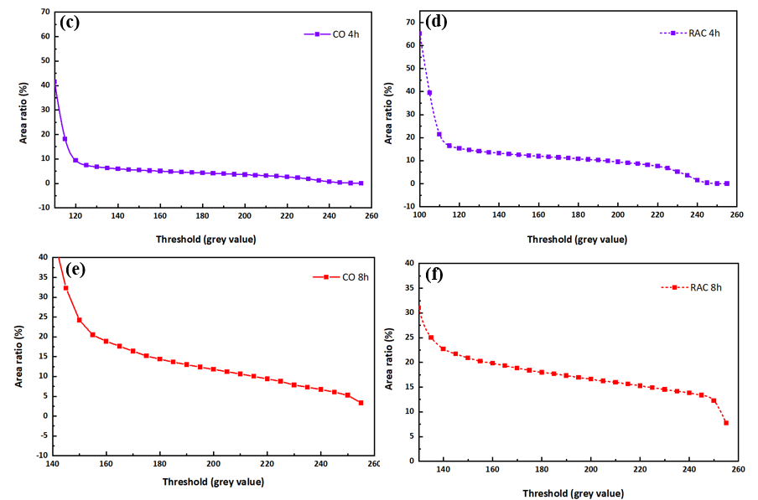

Supplementary Fig. 1. Sensitivity study

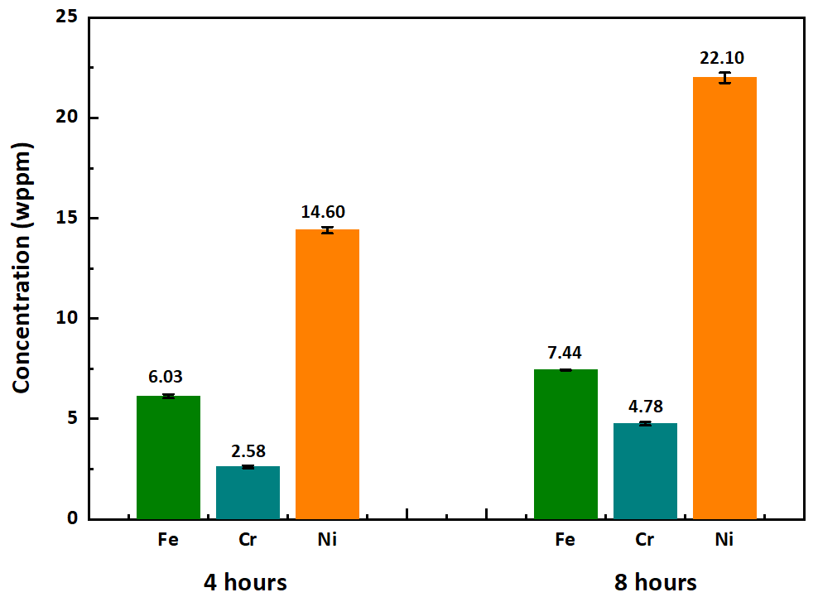

Summentary Fig. 2. Solubility data